CS308 Folio Tracker Initial GUI and Back-end API Design

Overview

This program is an application used to track the value of stock portfolios. Users of the program can open several different stock options, follow the current price of the stocks that they own, and sell stocks. The overall profit of their account can also be calculated within the program.

In figure 1 it can be seen that multiple portfolios can be seen at any given time and also the overall value of the holding is calculated and displayed on the portfolio.

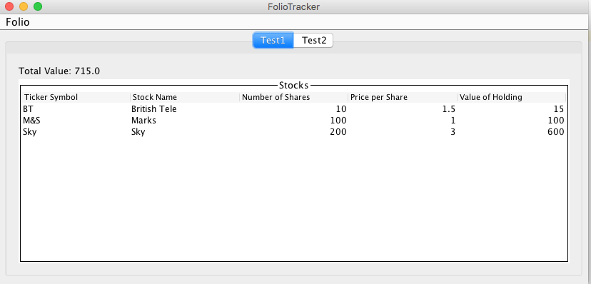

Figure 1 - Overview of Folio Tracker

Here this is where the user can design of the overall GUI used to interact with the stocks in portfolios. It is show than multiple portfolios can be opened in different tabs.

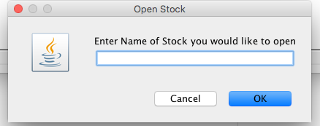

Figure 2 - Opening a stock pop up

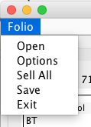

Figure 3 - Drop down option menu

UML Diagram

Specification API

Screenshots of the GUI